# CSC410, Fall 2016 - Assignment 2

Name: Jinnan Lu

Student Number: 997698807

Lecture: Monday

Due: Tuesday, 6th December 2016 at 23:59

# Part1: Line Coverage Test

## 1. Exploratory Testing

Scenario1: Test “Start” and “Stop” button works as expected.

1. click “Start” button, result: NPCs move
2. click “Start” button, result: NPCs still move
3. click “Stop” button, result: NPCs stop
4. click “Stop” button, result: NPCs keep still

Scenario2: Test “Score” is correct.

1. click “Start” button, result: NPCs move, score=0
2. press “left” key then click “Stop”, result:player moves left by 1 unit, score=10
3. press “left” key then click “Stop”, result: player moves left by 1 unit, score=20

Scenario3: Test player can not move to forbidden region

1. click “Start” button, press “up” key twice, result: player change its face up, but does not move
2. press “left key” seven times, result: player moves left by 6 units then keeps still

## 2 Measure Code Coverage

Following is the code coverage result for jpacman-framework. According to this report, coverage percentage of jpacman-framework is 80.7%. (Note the Eclemma was installed in Eclipse)



When looking at detail level report, we found three least covered application classes (0 for each of them):

1. nl.tudelft.jpacman.level.CollisionInteractionMap

Test for this class need to be improved. We should add test for the following function

|  |
| --- |
| **public** <C1 **extends** Unit, C2 **extends** Unit> **void** onCollision(  Class<C1> collider, Class<C2> collidee,  CollisionHandler<C1, C2> handler) |

We need to test that after setting handler can be added, and the added handlers are symmetric.

We also should add test for the following function

|  |
| --- |
| **public** <C1 **extends** Unit, C2 **extends** Unit> **void** onCollision(  Class<C1> collider, Class<C2> collidee, **boolean** symetric,  CollisionHandler<C1, C2> handler) |

We need to test that handlers can be added with this function, and the symmetric works as expected.

We also should add test for the following function

|  |
| --- |
| **public** <C1 **extends** Unit, C2 **extends** Unit> **void** collide(C1 collider,  C2 collidee) |

We can first add mocks for the handler map, then test that correct handlers are invoked by this function.

1. nl.tudelft.jpacman.level.DefaultPlayerInteractionMap

Test for this class need to be improved. We can add test to the following function by passing different pairs of mocked Units to it. And verify that by calling this function, expected action on those Units are invoked.

|  |
| --- |
| **public** **void** collide(Unit mover, Unit movedInto) |

1. nl.tudelft.jpacman.PacmanConfigurationException

This is adequate since the class is just a subclass of RuntimeException, no extra logic in it.

## Compare results with/without –ea option

Following is coverage result without –ea option.



Following is coverage result with –ea option.



With -ea option, assertions are enabled, so the number covered instructions is increased, and so does the coverage percentage.

# Part2: Mutation Test

Following is mutation test result for jpacman-framework. (Note these are generated by Pitclipse from Eclipse Marketplace)

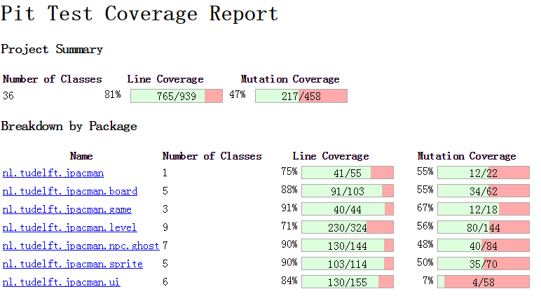

The line coverage percentage is very close to that given by EclEmma/Jacoco. This is because before running the tests, PIT will perform a traditional line coverage analysis for the tests, then use this data along with the timings of the tests to pick a set of test cases targeted at the mutated code.

Following are test results for several mutators:

With only Conditionals Boundary Mutator

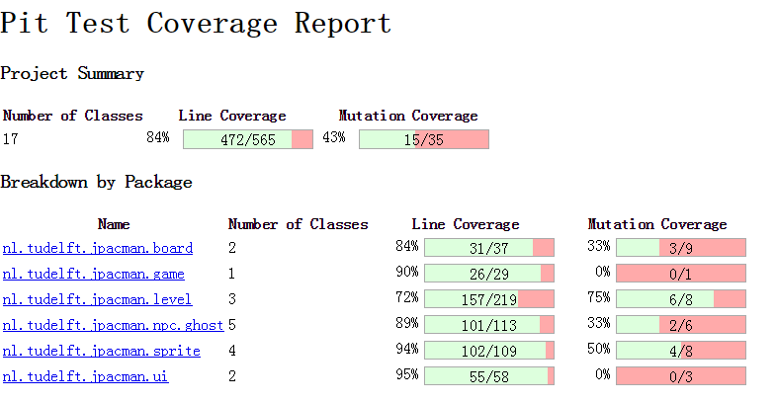

With only Increments Mutator

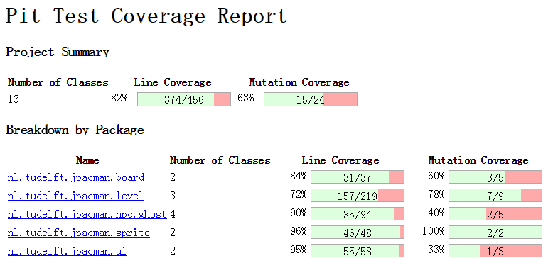

With only Math Mutator

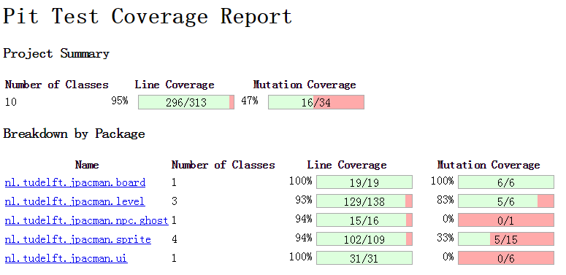

From the above results, we can see that PIT will select the classes and lines according to the given mutators, and then apply the mutation. In this project, tests for all of the 3 kinds of mutations need to be improved.

In the detailed report, we can find the following that survived mutation test:

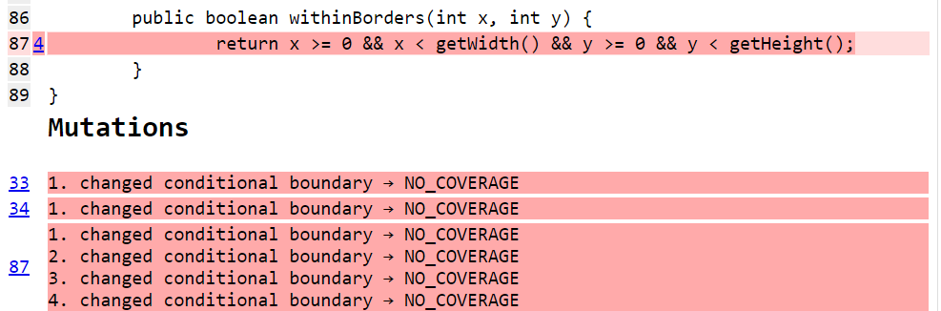

From above report, we can see that conditional boundary mutation for withinBorders function survives. We can add the following test cases to improve the coverage:

The corner points (0,0), (0, Y_MAX), (X_MAX, 0), (X_MAX, Y_MAX) are within borders

The points (0, Y_MAX+1), (X_MAX+1,0), (-1,0), (0, -1) are out of borders.

Follow are test cases for the above.

|  |
| --- |
| /**  * Verifies the square at x0y0 is indeed within the borders.  */  @Test  **public** **void** verifyX0Y0WithinBorders() {  *assertTrue*(board.withinBorders(0, 0));  }  /**  * Verifies the square at x0y2 is indeed within the borders.  */  @Test  **public** **void** verifyX0Y2WithinBorders() {  *assertTrue*(board.withinBorders(0, 2));  }    /**  * Verifies the square at x1y0 is indeed within the borders.  */  @Test  **public** **void** verifyX1Y0WithinBorders() {  *assertTrue*(board.withinBorders(1, 0));  }    /**  * Verifies the square at x1y2 is indeed within the borders.  */  @Test  **public** **void** verifyX1Y2WithinBorders() {  *assertTrue*(board.withinBorders(1, 2));  }    /**  * Verifies the square at x0y3 is indeed out of the borders.  */  @Test  **public** **void** verifyX0Y3OutOfBorders() {  *assertFalse*(board.withinBorders(0, 3));  }    /**  * Verifies the square at x2y0 is indeed out of the borders.  */  @Test  **public** **void** verifyX2Y0OutOfBorders() {  *assertFalse*(board.withinBorders(2, 0));  }    /**  * Verifies the square at x(-1)y0 is indeed out of the borders.  */  @Test  **public** **void** verifyX_1Y0OutOfBorders() {  *assertFalse*(board.withinBorders(-1, 0));  }    /**  * Verifies the square at x0y(-1) is indeed out of the borders.  */  @Test  **public** **void** verifyX0Y_1OutOfBorders() {  *assertFalse*(board.withinBorders(0, -1));  } |

With the above change, the coverage increases (see below).

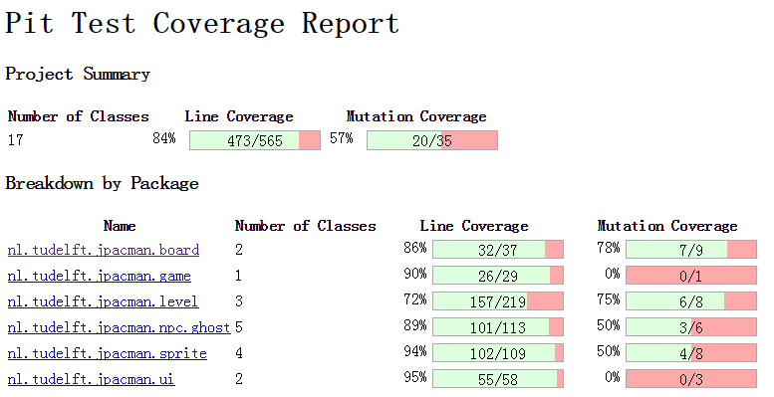

# Part 3: Extend Test Suite with Symbolic Execution

Following is jpf file for withinBorders function.

|  |
| --- |
| # here write your own classpath and un-comment  target = nl.tudelft.jpacman.board.Board  classpath=  symbolic.method= nl.tudelft.jpacman.board.Board.withinBorders(sym#sym)  # listener to print information: PCs, test cases  listener = gov.nasa.jpf.symbc.SymbolicListener  # The following JPF options are usually used for SPF as well:  # no state matching  vm.storage.class=nil  # do not stop at first error  search.multiple_errors=true |

Following is test cases for withinBorders function. It test points within borders, including corner points, as well as points outside borders.

|  |
| --- |
| **package** nl.tudelft.jpacman.board;  **import** **static** org.junit.Assert.*assertFalse*;  **import** **static** org.junit.Assert.*assertTrue*;  **import** **static** org.mockito.Mockito.*mock*;  **import** org.junit.Before;  **import** org.junit.Test;  **public** **class** JPFBoardTest {  **private** Board board;    **private** **final** Square x0y0 = *mock*(Square.**class**);  **private** **final** Square x0y1 = *mock*(Square.**class**);  **private** **final** Square x0y2 = *mock*(Square.**class**);  **private** **final** Square x1y0 = *mock*(Square.**class**);  **private** **final** Square x1y1 = *mock*(Square.**class**);  **private** **final** Square x1y2 = *mock*(Square.**class**);    **private** **static** **final** **int** ***MAX_WIDTH*** = 2;  **private** **static** **final** **int** ***MAX_HEIGHT*** = 3;    /**  * Setup a board that can be used for testing.  */  @Before  **public** **void** setUp() {  Square[][] grid = **new** Square[***MAX_WIDTH***][***MAX_HEIGHT***];  grid[0][0] = x0y0;  grid[0][1] = x0y1;  grid[0][2] = x0y2;  grid[1][0] = x1y0;  grid[1][1] = x1y1;  grid[1][2] = x1y2;  board = **new** Board(grid);  }      /**  * Verifies the square at x0y0 is indeed within the borders.  */  @Test  **public** **void** verifyX0Y0WithinBorders() {  *assertTrue*(board.withinBorders(0, 0));  }    /**  * Verifies the square at x0y1 is indeed within the borders.  */  @Test  **public** **void** verifyX0Y1WithinBorders() {  *assertTrue*(board.withinBorders(0, 1));  }    /**  * Verifies the square at x0y2 is indeed within the borders.  */  @Test  **public** **void** verifyX0Y2WithinBorders() {  *assertTrue*(board.withinBorders(0, 2));  }    /**  * Verifies the square at x1y0 is indeed within the borders.  */  @Test  **public** **void** verifyX1Y0WithinBorders() {  *assertTrue*(board.withinBorders(1, 0));  }    /**  * Verifies the square at x1y1 is indeed within the borders.  */  @Test  **public** **void** verifyX1Y1WithinBorders() {  *assertTrue*(board.withinBorders(1, 1));  }    /**  * Verifies the square at x1y2 is indeed within the borders.  */  @Test  **public** **void** verifyX1Y2WithinBorders() {  *assertTrue*(board.withinBorders(1, 2));  }    /**  * Verifies the square at x0y3 is indeed out of the borders.  */  @Test  **public** **void** verifyX0Y3OutOfBorders() {  *assertFalse*(board.withinBorders(0, 3));  }    /**  * Verifies the square at x2y0 is indeed out of the borders.  */  @Test  **public** **void** verifyX2Y0OutOfBorders() {  *assertFalse*(board.withinBorders(2, 0));  }    /**  * Verifies the square at x(-1)y0 is indeed out of the borders.  */  @Test  **public** **void** verifyX_1Y0OutOfBorders() {  *assertFalse*(board.withinBorders(-1, 0));  }    /**  * Verifies the square at x0y(-1) is indeed out of the borders.  */  @Test  **public** **void** verifyX0Y_1OutOfBorders() {  *assertFalse*(board.withinBorders(0, -1));  }  } |

# Part 4: Freeze/Unfreeze Feature

We implemented this freeze/unfreeze feature by adding a state variable isFreeze to Level class. And before doing the move operation, we will check the isFreeze. If it is true, and the Unit object is a NPC, then we finish the move operation by doing nothing.

To test this new feature, we first verify that the freeze/unfreeze can change the state of Level correctly, and does not interfere with start/stop.

|  |
| --- |
| /**  * Validates the state of the level when it isn't started yet.  */  @Test  **public** **void** noFreeze() {  *assertFalse*(level.isFreeze());  }    /**  * Validates the state of the level when it is unfrozen without freeze.  */  @Test  **public** **void** unfreeze() {  level.unfreeze();  *assertFalse*(level.isFreeze());  }    /**  * Validates the state of the level when it is frozen.  */  @Test  **public** **void** freeze() {  level.freeze();  *assertTrue*(level.isFreeze());  }    /**  * Validates the state of the level when it is frozen then unfrozen.  */  @Test  **public** **void** freezeUnfreeze() {  level.freeze();  level.unfreeze();  *assertFalse*(level.isFreeze());  }    /**  * Validate the freeze feature does not interfere with start/stop  */  @Test  **public** **void** freezeAndStart() {  *assertFalse*(level.isInProgress());  *assertFalse*(level.isFreeze());  level.start();  *assertTrue*(level.isInProgress());  *assertFalse*(level.isFreeze());  level.freeze();  *assertTrue*(level.isInProgress());  *assertTrue*(level.isFreeze());  level.unfreeze();  *assertTrue*(level.isInProgress());  *assertFalse*(level.isFreeze());  level.stop();  *assertFalse*(level.isInProgress());  *assertFalse*(level.isFreeze());  } |

Then we verify that 1. when in freeze state, NPCs can not move, 2. when in unfreeze state, NPCs can move, 3. when in freeze state, player can move.

|  |
| --- |
| /**  * Verify that when freezed, NPC can not move  */  @Test  **public** **void** NpcCannotMoveWhenFreeze() {  level.start();  level.freeze();  NPC npc = *mock*(NPC.**class**);  Square loc = *mock*(Square.**class**);  Square dest = *mock*(Square.**class**);  Mockito.*doReturn*(loc).when(npc).getSquare();  Mockito.*doReturn*(dest).when(loc).getSquareAt(Mockito.*any*());  Mockito.*doReturn*(**true**).when(dest).isAccessibleTo(Mockito.*any*());  Mockito.*doReturn*(**new** ArrayList<Unit>()).when(dest).getOccupants();  Mockito.*doNothing*().when(npc).occupy(Mockito.*any*());  level.move(npc, Direction.***NORTH***);  Mockito.*verify*(npc, Mockito.*times*(0)).occupy(dest);  }    /**  * Verify that when unfreezed, NPC can move  */  @Test  **public** **void** NpcCanMoveWhenUnfreeze() {  level.start();  level.freeze();  level.unfreeze();  NPC npc = *mock*(NPC.**class**);  Square loc = *mock*(Square.**class**);  Square dest = *mock*(Square.**class**);  Mockito.*doReturn*(loc).when(npc).getSquare();  Mockito.*doReturn*(dest).when(loc).getSquareAt(Mockito.*any*());  Mockito.*doReturn*(**true**).when(dest).isAccessibleTo(Mockito.*any*());  Mockito.*doReturn*(**new** ArrayList<Unit>()).when(dest).getOccupants();  Mockito.*doNothing*().when(npc).occupy(Mockito.*any*());  level.move(npc, Direction.***NORTH***);  Mockito.*verify*(npc, Mockito.*times*(1)).occupy(dest);  }    /**  * Verify that when freezed, player can move  */  @Test  **public** **void** PlayerCanMoveWhenFreeze() {  level.start();  level.freeze();  Player player = *mock*(Player.**class**);  Square loc = *mock*(Square.**class**);  Square dest = *mock*(Square.**class**);  Mockito.*doReturn*(loc).when(player).getSquare();  Mockito.*doReturn*(dest).when(loc).getSquareAt(Mockito.*any*());  Mockito.*doReturn*(**true**).when(dest).isAccessibleTo(Mockito.*any*());  Mockito.*doReturn*(**new** ArrayList<Unit>()).when(dest).getOccupants();  Mockito.*doNothing*().when(player).occupy(Mockito.*any*());  level.move(player, Direction.***NORTH***);  Mockito.*verify*(player, Mockito.*times*(1)).occupy(dest);  } |